**CREATION OF CURSORS**

CREATE TABLE BANKDETAILS(ACCNO INT,NAME VARCHAR2(15),BALANCE INT, ADATE DATE);

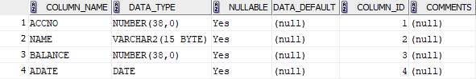

INSERT INTO BANKDETAILS VALUES(1001,'ABY',3005,'10-OCT-15');

INSERT INTO BANKDETAILS VALUES(1002,'ALAN',4000,'05-MAY-95');

INSERT INTO BANKDETAILS VALUES(1003,'AMAL',5000,'16-MAR-92');

INSERT INTO BANKDETAILS VALUES(1004,'JEFFIN',3500,'01-APR-50');

SELECT * FROM BANKDETAILS;

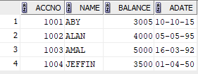

CREATE TABLE BANKNEW(ACCNO INT,INTR INT);

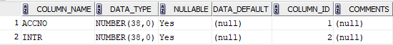

DECLARE CURSOR TEMP IS SELECT ACCNO,NAME,BALANCE,ADATE FROM BANKDETAILS;

TEMPVAR TEMP %ROWTYPE;

INTR INT;

BEGIN OPEN TEMP;

LOOP

FETCH TEMP INTO TEMPVAR;

EXIT WHEN TEMP%NOTFOUND;

INTR:=.08*TEMPVAR.BALANCE;

INSERT INTO BANKNEW VALUES(TEMPVAR.ACCNO,INTR);

END LOOP;

CLOSE TEMP;

END;



SELECT * FROM BANKNEW;

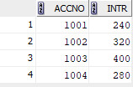

CREATE TABLE STUDENT (ID INT, NAME VARCHAR2(15), M1 INT, M2 INT, M3 INT, GRADE CHAR(2));

INSERT INTO STUDENT(ID, NAME, M1, M2, M3) VALUES (1, 'ALICE', 85, 90, 78);

INSERT INTO STUDENT(ID, NAME, M1, M2, M3) VALUES (2, 'BOB', 70, 75, 80);

INSERT INTO STUDENT(ID, NAME, M1, M2, M3) VALUES (3, 'CHARLIE', 95, 88, 92);

INSERT INTO STUDENT(ID, NAME, M1, M2, M3) VALUES (4, 'DAVID', 60, 65, 58);

INSERT INTO STUDENT(ID, NAME, M1, M2, M3) VALUES (5, 'EVE', 50, 55, 45);

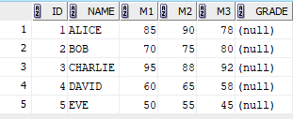

DECLARE

CURSOR CURSOR IS SELECT ID, M1, M2, M3 FROM STUDENT;

RECORDS CURSOR%ROWTYPE;

TOTAL INT;

GRADES CHAR(2);

BEGIN

OPEN CURSOR;

LOOP

FETCH CURSOR INTO RECORDS;

EXIT WHEN CURSOR%NOTFOUND;

TOTAL := RECORDS.M1 + RECORDS.M2 + RECORDS.M3;

IF TOTAL >= 240 THEN

GRADES := 'A';

ELSIF TOTAL >= 180 THEN

GRADES := 'B';

ELSIF TOTAL >= 120 THEN

GRADES := 'C';

ELSE

GRADES := 'D';

END IF;

UPDATE STUDENT SET GRADE = GRADES WHERE ID = RECORDS.ID;

END LOOP;

CLOSE CURSOR;

END;



SELECT * FROM STUDENT;

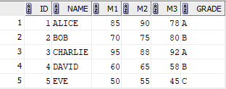

CREATE TABLE PEOPLE_LIST (ID INT, NAME VARCHAR2(50), DT_JOINING DATE,PLACE VARCHAR2(50));

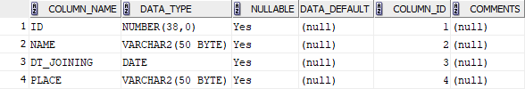

INSERT INTO PEOPLE_LIST VALUES (1, 'JOHN', TO_DATE('01-JAN-2010', 'DD-MON-YYYY'), 'NEW YORK');

INSERT INTO PEOPLE_LIST VALUES (2, 'JANE', TO_DATE('01-JAN-2005', 'DD-MON-YYYY'), 'LOS ANGELES');

INSERT INTO PEOPLE_LIST VALUES (3, 'MIKE', TO_DATE('01-JAN-2018', 'DD-MON-YYYY'), 'CHICAGO');

INSERT INTO PEOPLE_LIST VALUES (4, 'SARA', TO_DATE('01-JAN-2000', 'DD-MON-YYYY'), 'MIAMI');

INSERT INTO PEOPLE_LIST VALUES (5, 'TOM', TO_DATE('01-JAN-2012', 'DD-MON-YYYY'), 'SEATTLE');

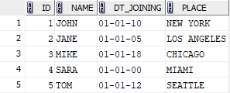

CREATE TABLE EXP_LIST (ID INT, NAME VARCHAR2(50), EXPERIENCE INT);

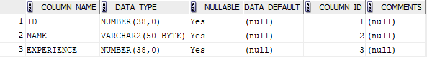

DECLARE

CURSOR PEOPLE_CURSOR IS

SELECT ID, NAME, DT_JOINING FROM PEOPLE_LIST;

TEMPVAR PEOPLE_CURSOR%ROWTYPE;

EXPERIENCE INT;

BEGIN

OPEN PEOPLE_CURSOR;

LOOP

FETCH PEOPLE_CURSOR INTO TEMPVAR;

EXIT WHEN PEOPLE_CURSOR%NOTFOUND;

EXPERIENCE := TRUNC(MONTHS_BETWEEN(SYSDATE, TEMPVAR.DT_JOINING) / 12);

IF EXPERIENCE > 10 THEN

INSERT INTO EXP_LIST VALUES (TEMPVAR.ID, TEMPVAR.NAME, EXPERIENCE);

END IF;

END LOOP;

CLOSE PEOPLE_CURSOR;

END;



SELECT * FROM EXP_LIST;

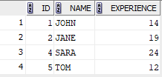

CREATE TABLE EMPLOYEE_LIST (ID INT, NAME VARCHAR2(50), MONTHLY_SALARY INT);

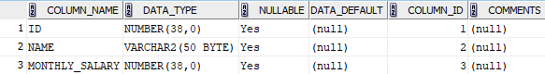

INSERT INTO EMPLOYEE_LIST VALUES (1, 'ALICE', 4000);

INSERT INTO EMPLOYEE_LIST VALUES (2, 'BOB', 6000);

INSERT INTO EMPLOYEE_LIST VALUES (3, 'CHARLIE', 8000);

INSERT INTO EMPLOYEE_LIST VALUES (4, 'DAVID', 12000);

INSERT INTO EMPLOYEE_LIST VALUES (5, 'EVE', 30000);

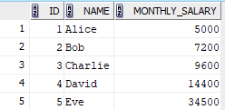

DECLARE

CURSOR EMP_CURSOR IS

SELECT ID, MONTHLY_SALARY FROM EMPLOYEE_LIST;

TEMPVAR EMP_CURSOR%ROWTYPE;

NEW_SALARY INT;

BEGIN

OPEN EMP_CURSOR;

LOOP

FETCH EMP_CURSOR INTO TEMPVAR;

EXIT WHEN EMP_CURSOR%NOTFOUND;

IF TEMPVAR.MONTHLY_SALARY * 12 < 60000 THEN

NEW_SALARY := TEMPVAR.MONTHLY_SALARY * 1.25;

ELSIF TEMPVAR.MONTHLY_SALARY * 12 BETWEEN 60000 AND 200000 THEN

NEW_SALARY := TEMPVAR.MONTHLY_SALARY * 1.20;

ELSIF TEMPVAR.MONTHLY_SALARY * 12 BETWEEN 200000 AND 500000 THEN

NEW_SALARY := TEMPVAR.MONTHLY_SALARY * 1.15;

ELSE

NEW_SALARY := TEMPVAR.MONTHLY_SALARY * 1.10;

END IF;

UPDATE EMPLOYEE_LIST SET MONTHLY_SALARY = NEW_SALARY WHERE ID = TEMPVAR.ID;

END LOOP;

CLOSE EMP_CURSOR;

END;



SELECT * FROM EMPLOYEE_LIST;

